**Title Should Be Written In Times New Roman Font Size 18 and Centered Alignment**

bbbbbbbbba,* and ccccccccccccb

a)*Pipeline and Subsea System Engineering, Ocean and Aerospace Engineering Research Institute, Indonesia*

b)*Mechanical Engineering, Universitas Riau, Indonesia*

*Corresponding author: xxxxxxx@xxxx.edu

**Paper History**

Received: xxxxx

Received in revised form: xxxxx

Accepted: xxxxxxx

**ABSTRACT**

The abstract should be consisting summary for the paper. Total number of words in summary should be around 150 words.

**KEY WORDS:***Please give three to five key words for each paper, the keywords should be font Times New Roman ITALIC*.

**NOMENCLATURE**

*API* American Petroleum Institute

$ΔT$ Temperature Difference in and out

$F_{T}$ Thermal Expansion

$L_{A}$ Anchor Length

$ΔL$ Expansion

$F_{P}$ Pressure Force

$F_{F}$ Friction Force

$ε_{sd}$ Design Compressive Strain

$ε_{c}$ Critical Strain

**1.0 SUBTITLE**

Subtitle should be labeled as 1.0, 2.0 etc. The subtitle should write in Times New Roman and font size 10. TWO line space is required between the subtitles to the end of previous paragraph. Give ONE line between the main texts after the subtitle too. It is required ONE space between the number label and the Subtitle.

**1.1 Sub-Subtitles**

Give ONE line spacing between the Sub-subtitles to previous main text paragraph. No line spacing required between the Sub-subtitles to the main text paragraph after the Sub-subtitle. The subtitle should write in Times New Roman and font size 9. Please and Capitalize Each Word and **BOLD**all sub-subtitles.It is required ONE space between the number label and the Sub-subtitle.

**2.0 PAPER FORMAT**

**2.1 Font Format**

The font text should be Times New Roman for whole paper included main texts, title and subtitle. Title should be written in Times New Roman Font Size 18, Capital Letter for first alphabet of word, **BOLD** and centered alignment.Font size 10, **BOLD** and CAPITAL LETTERused for subtitle, (Example: 1.0 SUBTITLE, ABSTRACT,KEY WORDS, NOMENCLATURE). Sub-subtitle should be used font size 9, **BOLD** and CapitalizeEachWord. Font size 9 should use for other text in the paper. The KEYWORDS should be usedTimes New Roman*ITALIC*size 9.

**2.2 Spacing Format**

Please use single spacing 1.0 for whole paper. The spacing before and after should settled to 0 pt. Do not add space before or after paragraph. Besides, it is no line space between paragraphs in same subtitle or sub-subtitles.

Indentation for first paragraph after the Subtitle or Sub-subtitles is 0 cm for left and right and (None) Special. For second paragraph, the Indentation is 0 cm for left and right. However, the Special should settle to First Line by 0.5 cm. Please select justify alignment for whole texts inside paper except for the table and figure labels which can be fixed into one line only. A screen shoot example for the spacing format is shown in figure 1.

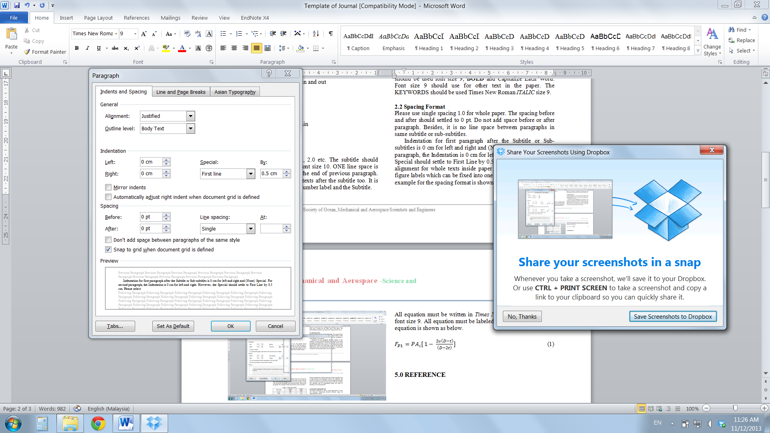

Figure 1: Spacing setup for the journal paper.

**3.0 TABLE AND FIGURE**

All tables must have a table label with the font size 9 before the table. No line spacing needed between the table’s labels with the table. But ONE line spae is needed between the tables’ labels with the previous paragraph and between the tables with the next paragraph. The example of table and its label as shown in table 1.

Table 1: SMYS and SMTS

|  |  |  |
| --- | --- | --- |
| API Grade | SMYS | SMTS |
| MPa | MPa |
| X42 | 289 | 413 |
| X46 | 317 | 434 |
| X52 | 358 | 455 |
| X56 | 386 | 489 |
| X60 | 413 | 517 |
| X65 | 448 | 530 |
| X70 | 482 | 565 |
| X80 | 551 | 620 |

The figure label should put after the figure. No line spacing is needed between figure and label. However, ONE line space is needed between figure with previous paragraph and between the figure labels with next paragraph. The Figure label should write in Times New Roman size 9. Example of the figure and it label as follow.

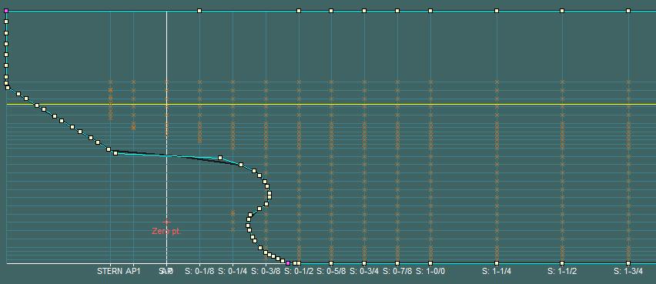

Figure 2: Stern hull designs for podded propulsion system.

All figure and table inside the paper should give a number follow by it sequence inside paper. Only short description is needed for every figure and table.

**4.0 EQUATION**

All equation must be written in *Times New Roman ITALIC* with font size 9. All equation must be labeled by number. An example equation is shown as below.

$F_{P1}=PA_{i}[ 1- \frac{2υ\left(D-t\right)}{\left(D-2t\right)}]$ (1)

$F_{F1}=fW_{S}x_{1}$ (2)

Please give ONE line space before equation, after equation and between equations.

**5.0 REFERENCE**

All citation in this paper must be labeled in square bracket and number. (*The example to make a citation in paper is in next paragraph)*.

It should be emphasized that the effective rescue may be carried out if two components are available: quick notification about the catastrophe and quick arriving to the rescue means to the point of distress [1]. According to Graham K Taylor, its main attributes wing in ground is :Turning the business machine faster, bringing destinations closer together, opening new routes within acceptable journey times, No sea motion, or sea sickness Low fatigue for occupants or equipment, No wash, no environmental damage to waterways, no effect on other waterway users, Immune to sea or river currents, will not hit floating objects such as driftwood, whales, etc, Shallow water operation, unaffected by tidal variation/water level, In the rescue environment Wing In Ground attributes are: Ability to cover a wide area within a short time, Rapid response capability – rapid closure [2, 3].

All references must be listed in “**REFERENCE”**. Please label the reference list by number. Also, please refer to the attachment for the detail to make the reference list.

Please give TWO line Space before the label “**REFERENCE”** with previous paragraph and give ONE line space after the label before start to list your references.

**5.0 CONCLUSION**

In conclusion, this paper explained the format used in Journal Ocean, Mechanical and Aerospace -Science and Engineering-. To easy the authors organize their paper, please download the empty template from the webpage. Inside the template, the format were pre-settled for authors in “Styles” function of Microsoft Word 2010. The format Styles Title, Subtitles, Sub-subtitle and normal were pre-set for author to format the paper.

**ACKNOWLEDGEMENTS**

The authors would like to convey a great appreciation to Ocean and Aerospace Engineering Research Institute, Japan for supporting this research.

**REFERENCE**

1. Palmer, A. C. and King,R. A. (2008).*Subsea Pipeline Engineering*:Pennwell Corporation.
2. Bai, Y. and Bai,Q. (2010).*Subsea Engineering Handbook*: Elsevier.
3. Shao, B., Yan, X.et al. (2011). *Reliability Analysis of Locally Thinned Submarine Pipelines in Cheng Dao Oil Field*, Applied Mechanics and Materials Vols. 94-96, pp: 1527-1530.
4. Li,Z.G (2010).Configuration of Submarine Pipeline for Deep water S-Lay Technique, *The International Society of Offshore and Polar Engineers.*